

300 DES/DX
Dehumidifier

TECHNICAL MANUAL

INSTALLATION, OPERATION & MAINTENANCE

Contents
TECHNICAL MANUAL 1
INSTALLATION, OPERATION & MAINTENANCE 1
NovelAire Technologies 3
300 DES/DX Dehumidifier Technical Manual 3
Table of Contents 3
1.0 DESCRIPTION 3
1.1 PRINCIPLE OF OPERATION 4
1.2 CABINET DESIGN AND SIZE 4
2.0 INSTALLATION 5
2.1 GUIDELINES AND CLEARANCE 6
2.2 DUCTWORK AND FILTRATION 6
2.3 ELECTRICAL CONNECTIONS 7
2.4 CONTROL WIRING 7
2.5 DRAIN LINE CONNECTION 8
2.6 SAFETY CONTROLS 8
2.7 REFRIGERANT CIRCUIT DATA 9
3.0 OPERATION AND CONTROL 10
3.1 CONTROL 10
3.1.1 First Time Start Up of the 300 DES/DX 10
3.1.2 Normal Operation of the 300 DES/DX 10
3.2 MAINTENANCE AND SERVICE 10
3.2.1 Routine Maintenance: 11
3.2.2 Troubleshooting: 11
3.3 INTEGRAL COMPONENTS 12
4.0 TECHNICAL INFORMATION 13
4.1 ELECTRICAL DATA: 13
4.2 SPECIFICATIONS 14
4.3 COMPRESSOR SPECIFICATIONS 15
4.4 TECHNICAL SUPPORT AND SERVICE 17
4.5 REFRIGERANT CHARGING 18
4.5.1 RECOVERY and EVACUATION 19
4.6 ELECTRICAL WIRING DIAGRAM 20
4.7 ELECTRICAL LADDER LOGIC 21
4.8 INSTALLATION DRAWINGS 22

NovelAire Technologies

300 DES/DX Dehumidifier Technical Manual

Table of Contents

SAFETY CONSIDERATION
Follow safety codes. Installation must be in compliance with local and national building codes. Read the instruction thoroughly before installation.

1.0 DESCRIPTION

The NovelAire 300 DES/DX Dehumidifier is designed to provide energy efficient dehumidification by combining the benefits of both DX cooling with desiccant dehumidification. The unit can be used for a variety of both commercial and residential applications.

The major components of this package mapped below (figure 1) are the proprietary NovelAire dehumidification wheel, a compressor, condensing coil, evaporation coil, process fan, regeneration fan and associated controls. Other elements include wheel drive motor and a control panel with fuses, relays and a small condenser fan speed control.

The process air flow delivers 300 CFM and has a dehumidification capacity of 6-8 pounds per hour of moisture removal with regards to inlet conditions. The capacity increases with increased moisture content in the space.

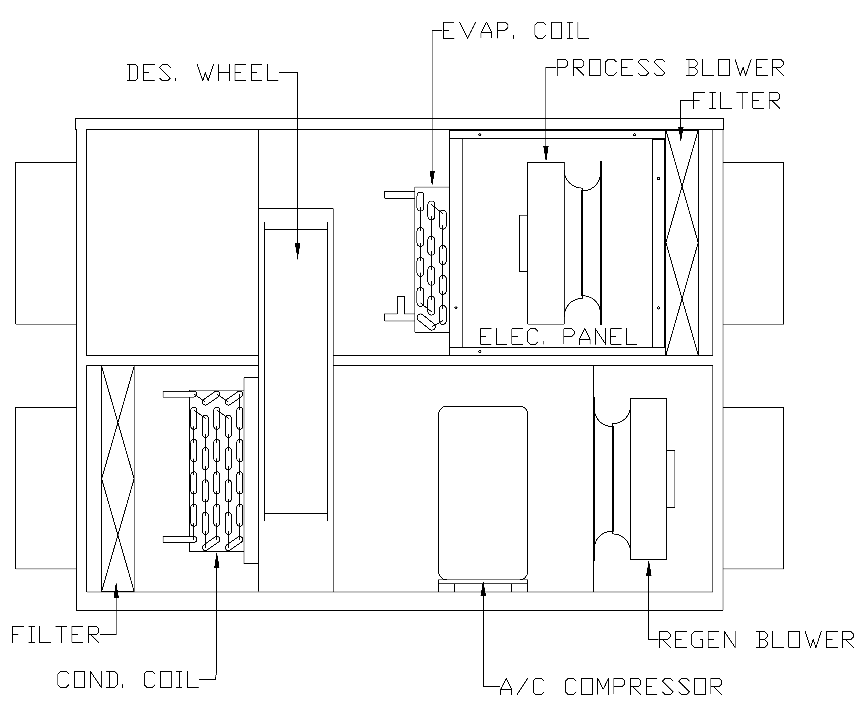

Return In

Supply Out

Exhaust Out

Outdoor In

Figure 1

1.1 PRINCIPLE OF OPERATION

The operation of the 300 DES/DX is driven by two counter current air streams flowing through the desiccant wheel as shown in Figure 1. Return air from the space is pushed through the unit by the process blower. The flow passes through an evaporator coil which removes heat from the airstream. The cool and saturated air is then passed through the rotating desiccant wheel which dehumidifies the airstream before it is sent back into the space. The supply air leaving the unit is at or slightly below space temperatures but much drier in moisture content. At the same time outdoor air is pulled through a separate air stream on the regeneration side of the unit. The flow passes through the condenser coil where the outdoor air uses waste heat from the refrigeration loop to regenerate the desiccant wheel. At the desiccant wheel, the hot, dry air from the condenser desorbs the moisture from the process airstream and discharges the air to the outdoor ambient conditions.

During operation the wheel rotation is continuous between the two air streams as they work together to produce a dry comfortable air supplied to the area.

1.2 CABINET DESIGN AND SIZE

The cabinet of the 300 DES/DX and all the components used in the design are of solid construction and selected to withstand rugged use in a wide variety of applications. The unit has a two-coat polyester pain finish, and the interior of the 300 DES/DX is laid out to minimize pressure drop through the system and to reduce the overall unit size. The chart below will provide you with basic information in regard to the units’ size.

The proprietary desiccant wheel is housed between two rigid face plates with a 40/60 split face area between process and regeneration to allow for low regeneration temperature operation. The face plates are designed and sealed to separate the process and regeneration air streams.

Weight: | 225 lbs. (43.9 kg) | Process Inlet Connection: | 10”
Length: | 40” (102cm) | Process Outlet Connection: | 10”
Height: | 30” (771cm) | Regen Inlet Connection: | 12”
Width: | 22” (55cm) | Regen Outlet Connection: | 12”
*** Note: Dimensions do not include factory installed duct collars ***

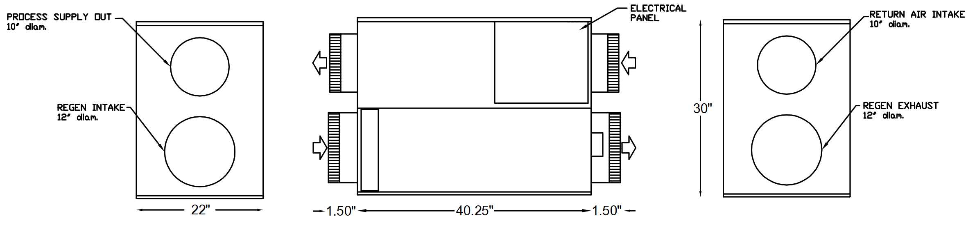

2.0 INSTALLATION

The NovelAire 300 DES/DX Desiccant Dehumidifier is typically installed as a stand-alone unit with its own return and supply air ducts as shown in Figure 3.

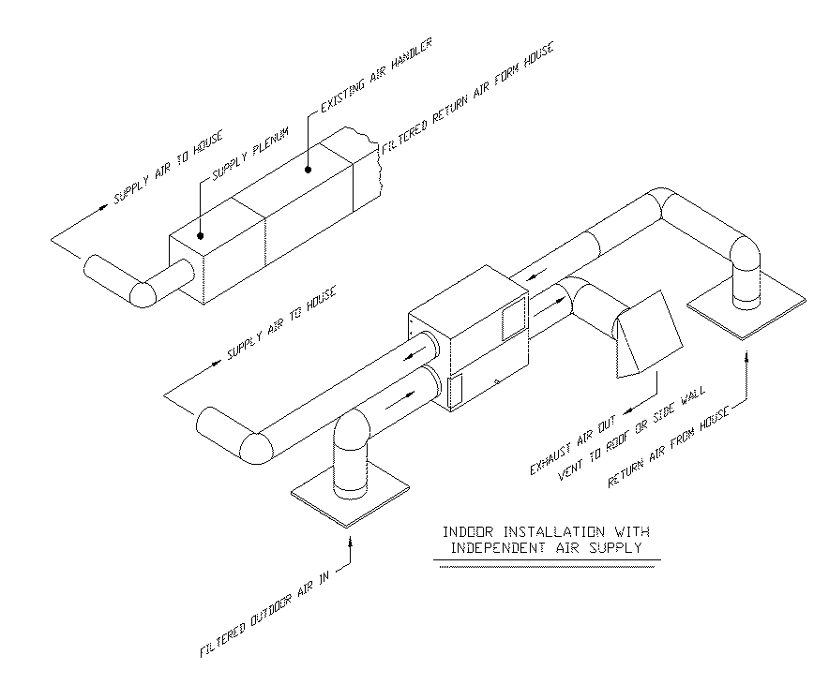

Figure 3

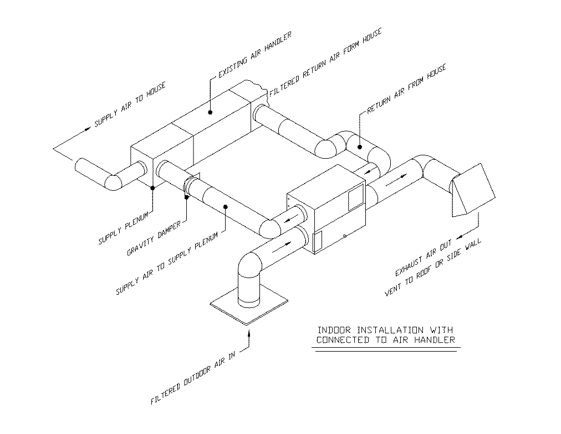
The unit can also be tied into the main air handler of the space with the supply out downstream of the evaporator coil. In this application the return and supply ducts are tied into the main trunk line. A gravity damper will need to be installed on the supply air duct from the 300 DES/DX in order to prevent back flow. Figure 4 depicts a typical installation with the unit connected to the air handler.

Figure 4

Booster fans should always be placed upstream of the unit and not be excessive in capacity or static pressure.

2.1 GUIDELINES AND CLEARANCE

IMPORTANT: The 300 DES/DX is designed to supply air at +0.3” H₂O. If the system pressure drop in the ducting is higher than this, air flow will be impeded, and unit performance will be affected.

IMPORTANT: To achieve proper operation of the dehumidifier, the supply air must always be connected to discharge inside the conditioned space, and the exhaust air must always be connected to discharge outside the conditioned space.

IMPORTANT: Consideration should be taken concerning the location of the ductwork to prevent the outdoor air intake from being too close to any exhaust duct that may already be present in the area.

IMPORTANT: All duct connections should meet all ACCA, ASHREA and NFPA 5000 Building Codes standards for the application.
24” Opposite Side

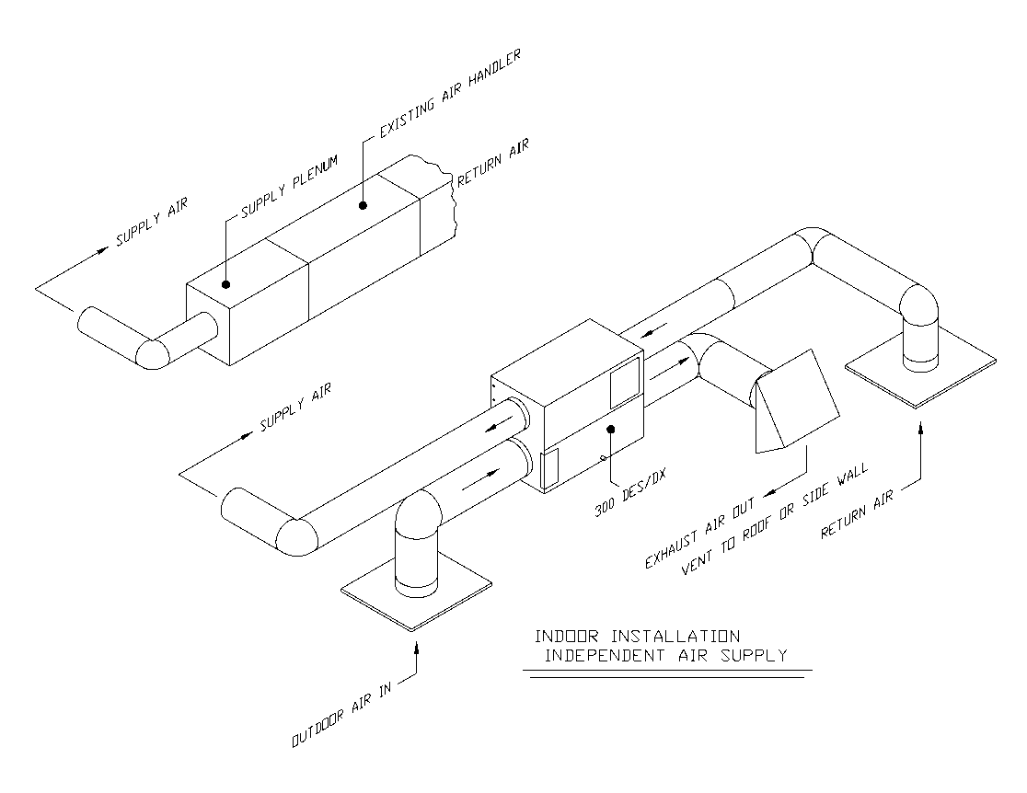
Clearance: When considering a location to install the 300 DES/DX it is important to note that both sides must have adequate clearance for service and maintenance. Factory recommendations are 36” on the control panel side of the unit and 24” on the opposite side as shown on illustration to the left.

36” Control Panel Side

2.2 DUCTWORK AND FILTRATION

As stated in section 1.2 the duct sizes are both 10” for the process air, and 12” for the regeneration air. It is acceptable to use either flexible ducting or hard pipe ducting with the 300 DES/DX. Always follow local codes when running ductwork and refer to specifications set forth in ACCA Manual D.

When shipped the unit is equipped with two (2) 14” x 18” x 1” filters for the process and regeneration air stream. It is important not to double filter the air stream as this may cause a problem with the unit performance. If a filter back grill is used on either side of the unit, remove the factory filters.

When sizing your return and regeneration inlet grills, always ensure you have at least 144 sq. in of surface face on each grill.

Example:
12” x 12” filter back grill = 144 sq. in. of surface space.

2.3 ELECTRICAL CONNECTIONS

SAFETY CONSIDERATION

Electrical installations must comply with the applicable provisions of the current editions of the National Electrical Safety Code, and any Local Codes where the unit is installed.

When installed, the unit must be electrically grounded in accordance with local codes, or in absence of local codes with the National Electrical Code, ANSI/NFPA70. See Section 4.1 for breaker sizing and electrical data. IMPORTANT: Use copper wire only between switch and disconnect.

The 300 DES/DX is designed to run at 208/230 VAC 1 phase power 60 Hz. The factory does not provide an On/Off switch on the unit. Therefore, it is required that a safety disconnect switch is installed. Locate disconnect within sight from and readily accessible from unit, per Section 440-14 of NEC. Within three feet (3’) of the unit per NEC Guidelines.

Ensure all field wiring complies with all national and local codes and the voltage is within the limits shown on the unit rating tag. The factory recommends contacting a local electrical contractor for field wiring to unit.

IMPORTANT: The 24VAC transformer is designed to accommodate 208VAC or 230VAC power. A switch is in the control panel and the proper voltage must be selected before operation of the unit.

2.4 CONTROL WIRING

The 300 DES/DX requires a humidistat for control and operation of the unit. A humidistat is available through NovelAire. The diagram below shows connections for a NovelAire humidistat. If the humidistat was purchased with the unit through NovelAire, use this wiring diagram illustrated in Figure 6 to make your connections.

If you are using a separate humidistat not provided by NovelAire, refer to that manufacturer’s wiring diagram.

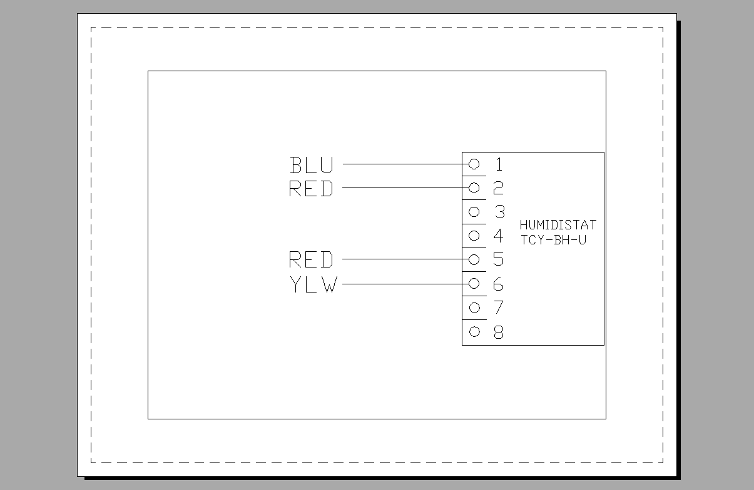
As seen in Figure 5 the LB located on the right is used for control wiring which contains four (4) wires. The four wires are as followed:

Red (1) 24V from internal transformer
Red (2) 24V from internal transformer
Blue Common wire
Yellow unit run signal input
*** A green wire is provided if Fan Only was requested when ordering ***
Figure 6

Figure 6 illustrates the wiring connection when using a NovelAire TCY-BH-U humidistat. Red (1) is used for powering the humidistat; Red (2) is used to close the contact when the humidistat calls for the unit to run.
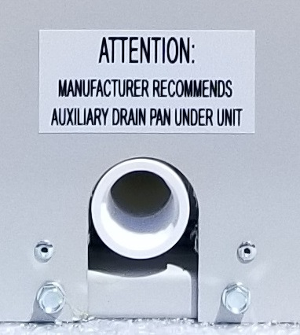

2.5 DRAIN LINE CONNECTION

The drain connection for the 300 DES/DX is located on the control panel side of the unit. The connection is a ¾” Female NPT PVC fitting as shown in Figure 7.

Figure 7

IMPORTANT: In all installations a secondary drain pan with a condensate overflow switch should be provided by the installer and placed under the entire unit. This pan is required in the event that there is a leak or the main drain is blocked. The overflow switch must be wired so as to disable unit operation in the event of a drain malfunction.

IMPORTANT: When plumbing the condensate drain line always confer with local plumbing codes or Uniform Plumbing Codes (UPC) to confirm proper installation.

IMPORTANT: DO NOT attempt to run unit without proper primary condensate drain line attached to the unit.

The drain line should have a slope of not less than 1/8” per foot and should be installed with a seal trap. A properly designed trap should allow water to drain out while preventing any air leakage through the drain line. Factory recommendation is a 2” trap for normal applications.

It is recommended that a “tee” be installed before the trap with a 4” riser and cap for maintenance purposes.

Always insulate drain lines in unconditioned space.

2.6 SAFETY CONTROLS

There are several safety devices associated with the 300 DES/DX that provide protection to the unit and the components. The tables below provide information on each of the safety devices. Should one of the components fail, always replace with the OEM specified component.

Fuses and Manual Resets:

Fuse | Size | Protection
F1 | 0.5 Amp | Transformer L1
F2 | 0.5 Amp | Transformer L2
F3 | 3.2 Amp | 24V Control

High Pressure Switch: (Auto Reset)

Switch | Cut Out | Cut In
High Pressure | 600 psig | 425 psig
Low Pressure | 75 psig | 105 psig

The internal compressor is thermally protected with an internal device that will disable the operation of the compressor when the internal temperature of the compressor reaches 302⁰F and will reset when it cools to 158⁰F.

2.7 REFRIGERANT CIRCUIT DATA

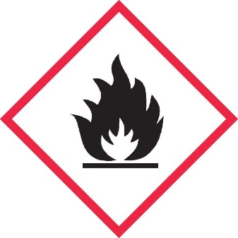

Refrigerant
Safety Group
A2L

Main Circuit: 1 lb 14 oz

WARNING

Do not use means to accelerate the defrosting process or to clean, other than those recommended by the manufacturer

The appliance shall be stored in a room without continuously operating ignition sources (for example: open flames, an operating gas appliance or an electric heater

Do not pierce or burn

Be aware that refrigerants may not contain an odor.

The unit is charged with R-454B from the factory which is classified as mildly flammable. Ensure that only equipment rated for higher pressures of R-454B are used for servicing. Under no circumstances should any work be conducted on the refrigerant lines which includes brazing and any other hot surface devices which could be a potential ignition source until a thorough recovery of refrigerant is done.

3.0 OPERATION AND CONTROL

The control panel for the 300 DES/DX is located at the side of the unit by the process intake duct. Once the 300 DES/DX is connected to the proper power source, and the drain line, ducting, and humidistat, the unit is essential ready to run.

3.1 CONTROL

A run signal from the humidistat will allow the unit to run. Ensure that humidistat set point is lower than the current level reading on the display. The “standard” %RH setting for the 300 DES/DX is 50%, however, the unit is designed to control at whatever %RH is set, up to the capacity of the system.

The 300 DES/DX is designed as a 100% return air system but could provide up to 20% outdoor air depending on the outdoor conditions, and up to the capacity of the system.

3.1.1 First Time Start Up of the 300 DES/DX
- Ensure there are no obstructions to the free flow of air into or out of the unit.
- Ensure that the drain line is correctly connected to the unit.
- Ensure that the unit has been properly and has the correct voltage.
- Ensure that the humidistat is connected, and display is illuminated.
- Ensure all mechanical and electrical codes have been followed
- Select the proper voltage for the transformer at the voltage control switch
- Turn on all circuit breakers and safety switches for the unit.
- Set the humidistat at desired level.
- The unit is now ready for routine operation.

3.1.2 Normal Operation of the 300 DES/DX
- The 300 DES/DX is operated by the humidistat. Lowering the set point below the current humidity level will start the unit and raising the set point above room conditions will stop the unit.
- For optimal performance of the unit factory recommendation is to leave the humidistat at the comfort level desired and allow the humidistat to cycle on and off as needed.
- NovelAire recommends that the minimum run time be set at 20 minutes to ensure that unit is not cycling too often.

3.2 MAINTENANCE AND SERVICE

IMPORTANT: This unit contains R-454B refrigerant that operates at extremely high pressure. Only trained service technicians are recommended by the factory to address suspected issues with refrigerant circuit.

The 300 DES/DX is a sealed system and comes from the factory pre-charged with proper refrigerant. It is not necessary to connect a gauge manifold to the system during regular maintenance. Gauges should only be connected if there is a suspected problem with the refrigeration charge.

3.2.1 Routine Maintenance:

SAFETY CONSIDERATION
Always disconnect power before performing service or maintenance on unit.

- Filters on outdoor inlet and return inlet should be inspected monthly and changed as needed. See Section 4, Technical Data for filter sizes.
- During peak operations ensure the filters are replaced, filters need to be replaced at least every 3 months.
- Condenser and evaporator coils should be inspected annually and cleaned with water as needed. (Heavy Detergents, Alkaline or Acidic based cleaners should not be used in standard cleaning.)
- Inspect drain line annually for algae and debris, you may pour one cup of standard bleach to one gallon of water to clear drain line.
- Seals on the desiccant wheel and the drive belt and drive system should be inspected annually.
- Motors and bearings are sealed and do not require lubrication.

3.2.2 Troubleshooting:

Understand that the 300 DES/DX is a complex piece of equipment. The troubleshooting guide is a basic guideline for service. Know your limitations before attempting to service. It is recommended that you contact a qualified HVAC service technician or our Technical Service Team if you are unsure of the problem. The contact information can be found in Section 4.

PROBLEM | CAUSE | SOLUTIONS
Entire unit not running | Humidistat set higher than actual space relative humidity | Lower humidity set point.
 | Humidistat not working | At control panel, install jumper across terminals 7 and 8. If unit comes up, humidistat is faulty or improperly wired.
 | No power to unit. | Check all fuses and breakers in relation to incoming power to the unit.
 | Internal power problem | Check F1-F3, and replace if needed. Use chart in section 2.4 for proper fuse sizes.
 | Unit tripped on high pressure | Contact service technician or factory to determine if the problem is the refrigeration circuit.
Unit running, but not dehumidifying | Desiccant wheel not rotating | Check MR1/MR2, reset if needed. Ensure belt is on the wheel and tight, check tensioner system. (note: contact factory if there is a problem with the drive system of the wheel)
Unit running, but not dehumidifying (cont.) | One or more fans not operating | Check for fan operation. If not running, check fan motor relays and or speed control. Regeneration fan speed control can be bypassed to troubleshoot.  (contact factory)
 | Airflow blocked | Check that all air inlets and outlets are not blocked and allow unobstructed air flows to and from unit.
 |  | Check and clean air filters as required.
Unit is cooling, but humidity is too high | Condensing coil is not heating regeneration air. | Ensure compressor is running, see below for details
 | Desiccant wheel not rotating | Check drives motor and belt.
 | Process air flow exceeds limits | Contact service technician or factory to determine airflow requirements.
Unit cycles on and off, no dehumidification | Unit tripped on high pressure | Contact service technician or factory to determine if the problem is the refrigeration circuit.

IMPORTANT: For further troubleshooting advice, contact the factory Technical Support, be sure to have the model and serial number of the unit when calling.

3.3 INTEGRAL COMPONENTS

MOTORS: The regeneration and process blowers are both PCS motors rated at 400 cfm at 2” H₂O. The regeneration blower is wired into a Nimbus™ speed controller that modulates the speed of the fan based on the condenser leaving air temperature. The process blower runs at full speed all the time.

REFRIGERANT CIRCUIT: The refrigerant circuit of the system is based on 12,000 btu/h capacity that contains a one (1) ton compressor, an evaporator, a condenser, and a factory set thermostatic expansion valve (TXV).

DESICCANT WHEEL: The wheel used in the 300 DES/DX units are manufactured by NovelAire Technologies and are the wheel technology is proprietary in nature. DES 440mm x 100 mm.

4.0 TECHNICAL INFORMATION

4.1 ELECTRICAL DATA:
The following electrical ratings, listed below, are posted in the Certification Construction Report filed with ETL and are valid for safe operation.

Voltage: | 208-230 VAC / 1 Phase / 50-60 Hz.
Unit FLA: | 8.3 Amps
Unit MCA: | 10.3 Amps
Unit MOP: | 20.0 Amps

Recommended Circuit Breaker Size: 20 AMP

The RLA of the unit is based on space and ambient conditions.

Motor | IM Number | Watts | RLA | FLA
Process Fan (300 CFM) | 19040022 | 230 W | .70 A | 1.0 A
Regen Fan (300 CFM) | 19040022 | 230 W | .70 A | 1.0 A
Gear Motor (7 RPM) | 19010075 | 37 W | .33 A | .25 A
Compressor (1 ton) | 502100100 | 1222 W | 5.6 A | 8.3 A

Figure 8: Control Panel

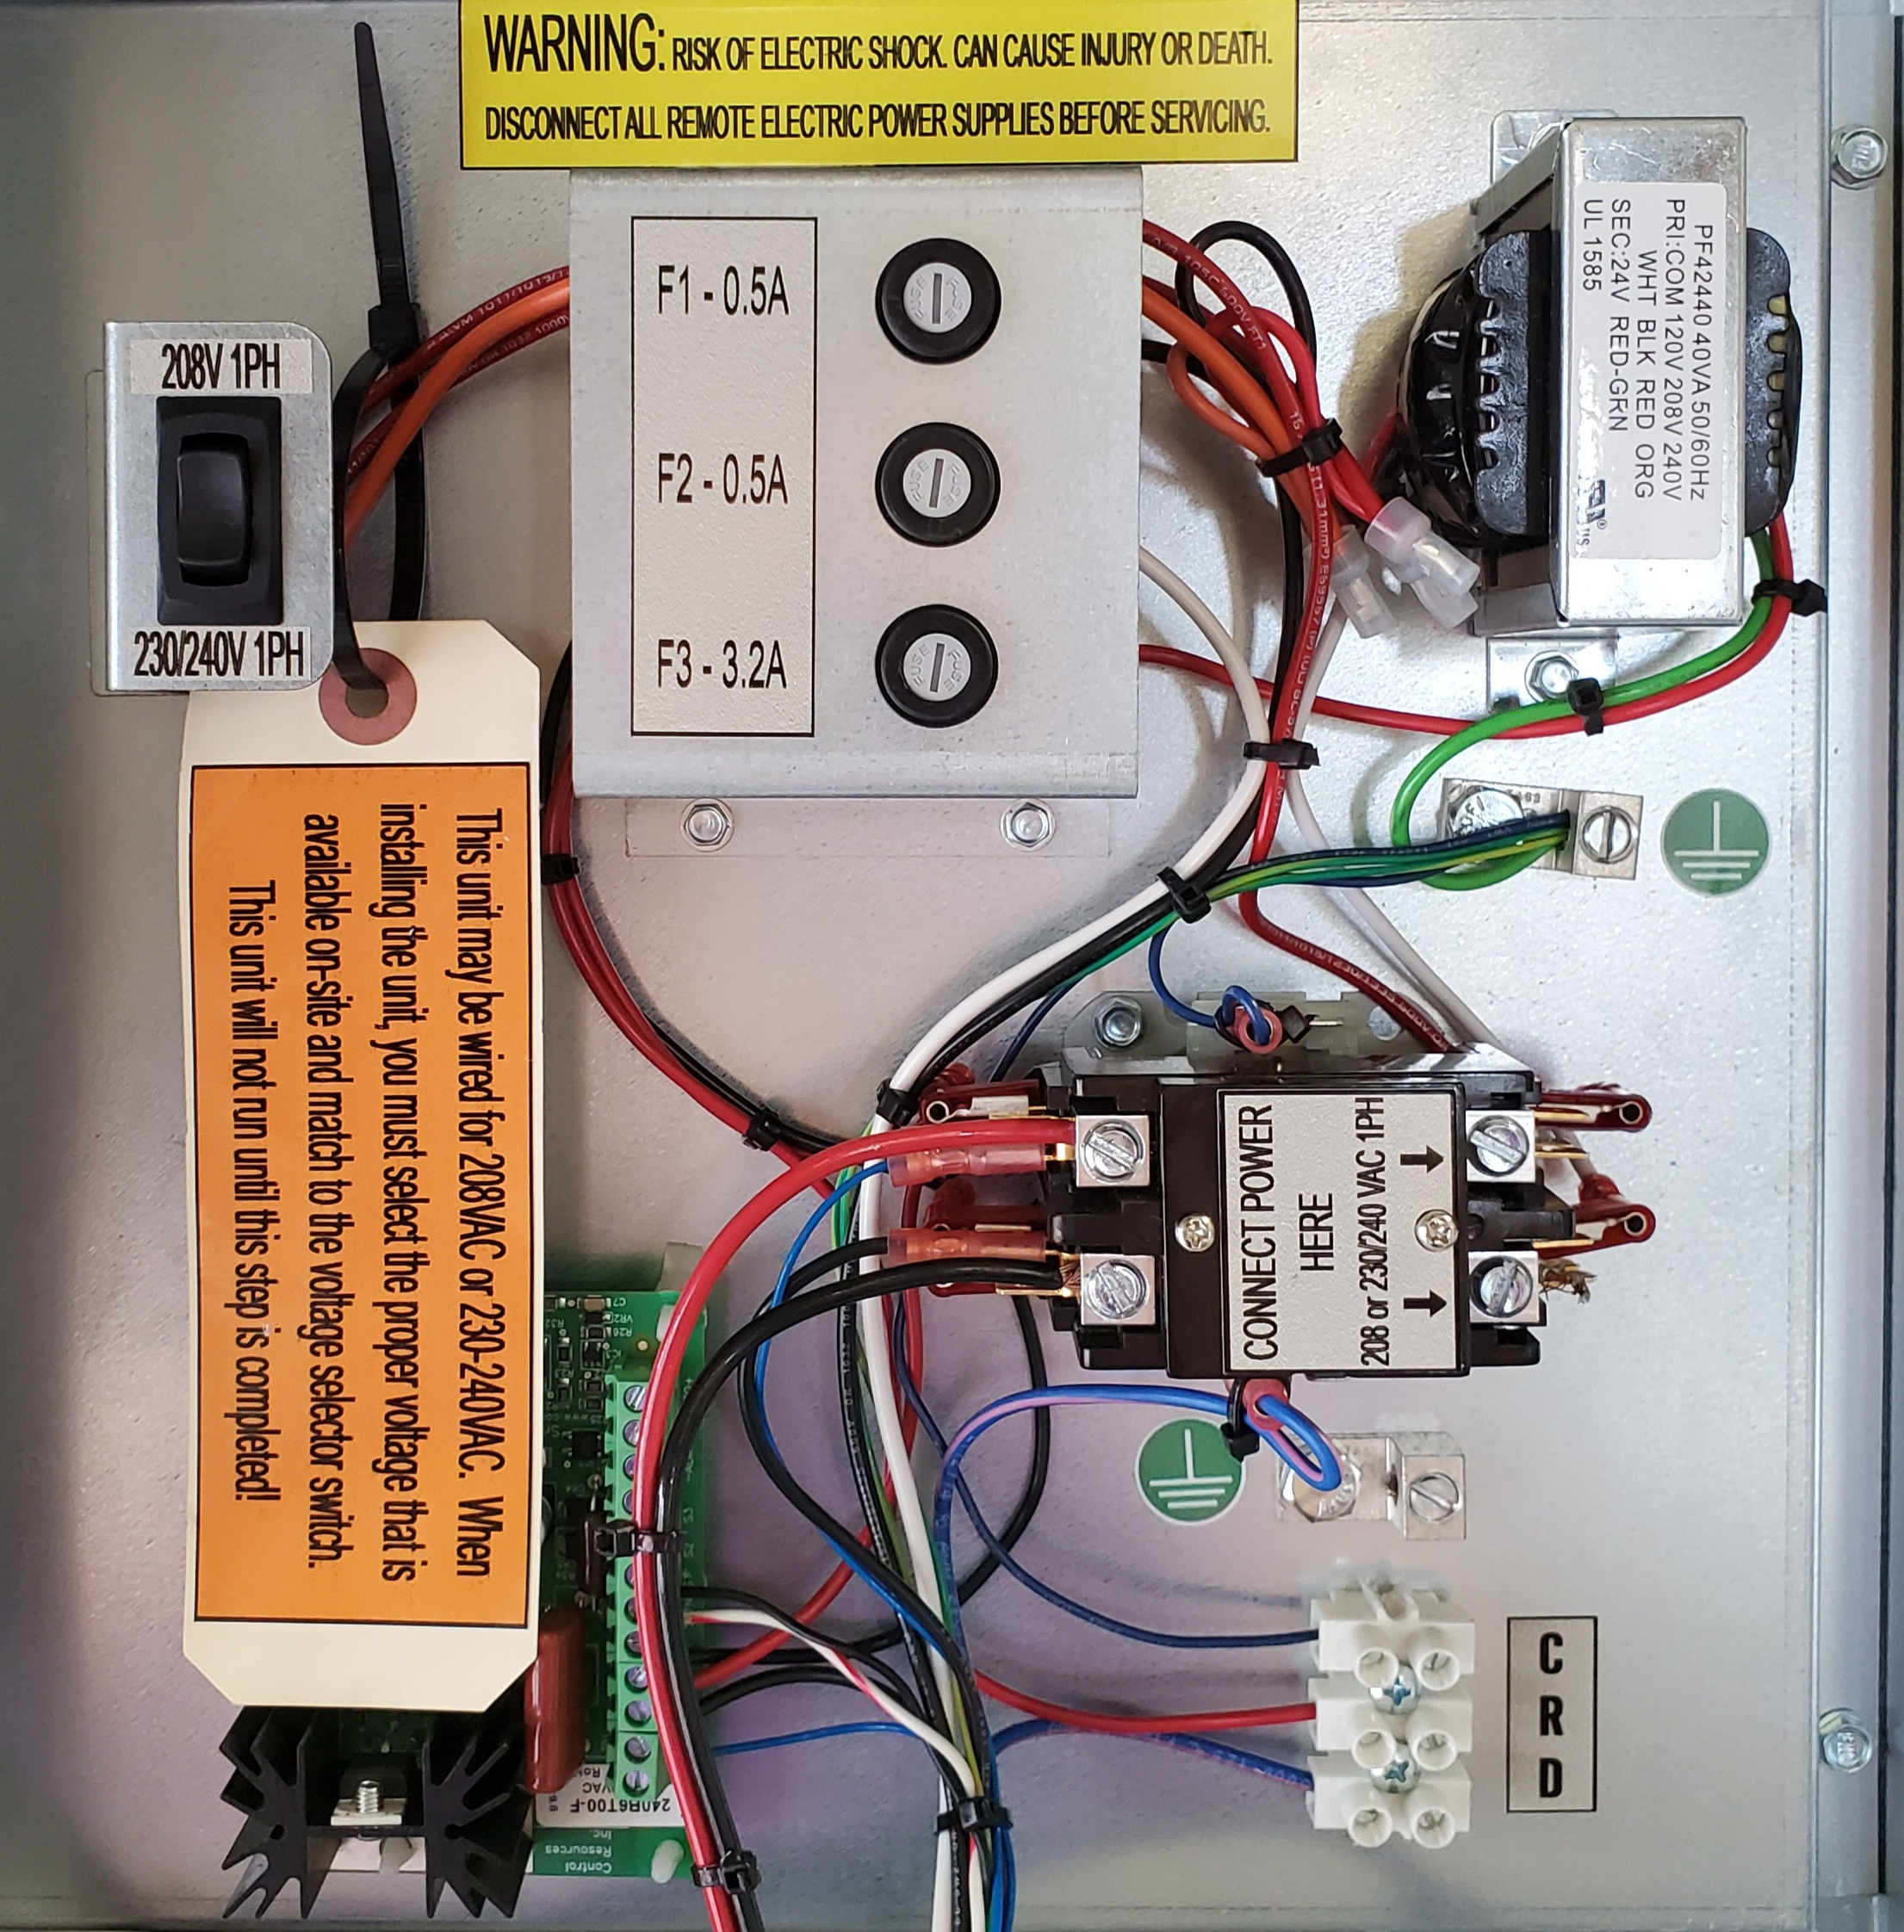

Mains Voltage Selector
24V Control Transformer

Fuses

High Voltage Power
Contactor
Nimbus® Speed Control

Low Voltage Terminal Block

4.2 SPECIFICATIONS

Model: | 300 DES/DX
Revision: | REV 3.0
Serial Number:
Voltage: | 208-230 VAC / 1 phase / 50-60 Hz
Cabinet | 20 gauge, galvanized metal w/ polyester coating
Control and Interlock: | 24 VAC (internal transformer)
Unit FLA: | 8.3 Amps
Unit MCA: | 10.3 Amps
Unit MOP: | 20.0 Amps
Size: | L 40” x W 30” x H 22”
Weight: | 225 lbs.
Process Inlet Duct Size: | 10”
Process Outlet Duct Size: | 10”
Regen Inlet Duct Size: | 12”
Regen Outlet Duct Size: | 12”
ETL Certifications: | Household And Similar Electrical Appliances, Part 1: General Requirements [UL 60335-1:2016 Ed.6] [CSA C22.2#60335- 1:2011Ed.1]  Household and Similar Electrical Appliances - Safety - Part 2 - 40: Particular Requirements for Electrical Heat Pumps, Air-Conditioners, and Dehumidifiers [UL 60335-2-40:2022 Ed.4] [CSA C22.2#60335-2-40:2022 Ed.4]
Process Volume: | 300 CFM
External Static: | 0.3” W.C.
Refrigerant | R-454B
Refrigerant Charge: | 1 lb. 14 oz.
Cooling Capacity: (Net) | 9,000 btu/H
Dehumidification Capacity: | 8.1 lbs./hr. @ (space conditions: 79⁰F / 84 gr/lb)  (outdoor conditions: 88⁰F / 126 gr/lb)
Desiccant Wheel: | 440mm x 100mm DES
Internal Filter Size: | 14” x 18” x 1” filters (2 each)

This unit has been authorized to mark certified and meets UL standards for Safety for Heating and Cooling Equipment UL 60335-2-40:2022 Ed.4 & CSA C22.2#60335-2-40:2022 Ed.4

Please record serial number and leave this paperwork after installation.

4.3 COMPRESSOR SPECIFICATIONS
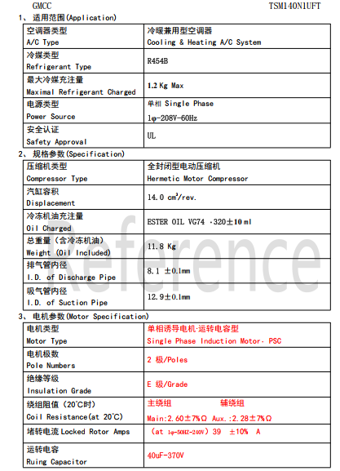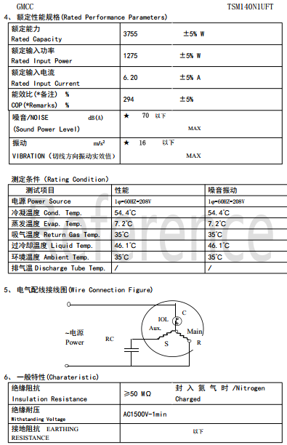

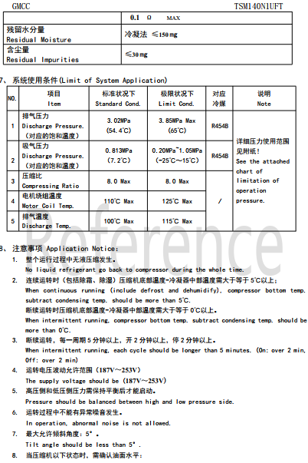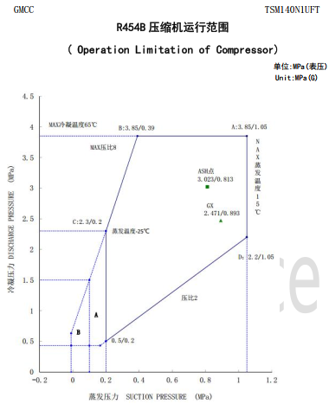

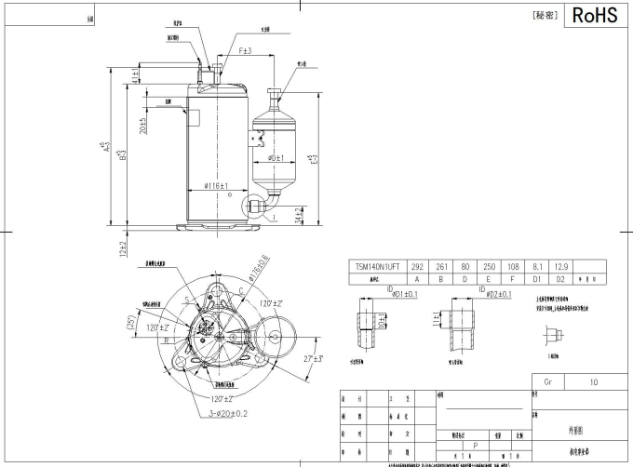

4.4 TECHNICAL SUPPORT AND SERVICE

Factory NovelAire Technologies
Address: 10132 Mammoth Drive
Baton Rouge, LA 70814-4420
Telephone: (225) 924-0427 or
(800) 762-1320
E-mail: service@novelaire.com

4.5 REFRIGERANT CHARGING

Refrigerant Charging Instructions for 300 DES/DX.

The 300 DES/DX comes with a factory charge of 1 pound 14 ounces. The unit is a sealed system and adjustment of charge is not needed. The unit is charged is confirmed using the sliding scale below. If there is a problem with the refrigerant circuit or there is a loss of charge for some reason, you may use the charging curve below to confirm the charge of the unit. (Note: R-454B is a blended refrigerant and must be charged as a liquid.) Always weigh in the charge at first and then use the following procedures to confirm proper operation of the system.

  - Measure the liquid line and temperature at the liquid line near the filter on the process outside of the unit.
  - Make sure the outdoor temperature is above 65 F and the unit is in a steady state.
  - After the unit has run for 15 minutes, plot the temperature and pressure using the charging chart below for the TXV valve.
  - Adjust the charge according to the chart set below.
  - Sub cool temperatures for the liquid line will run between 8° and 10°F.

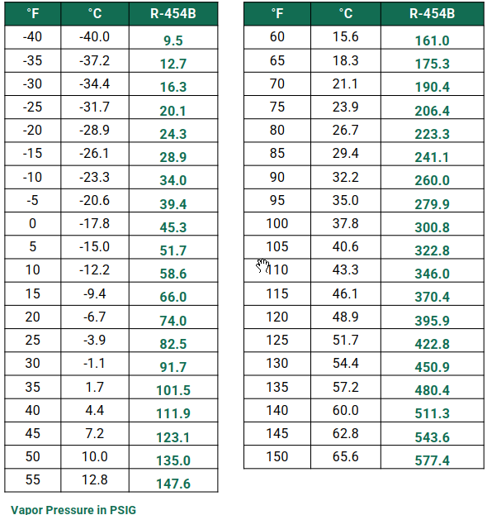

In addition to conventional charging procedures, the following requirements shall be followed:

- Ensure that contamination of different refrigerants does not occur when using charging equipment. Hoses or lines shall be as short as possible to minimize the amount of refrigerant contained in them.
- Cylinders shall be kept in an appropriate position according to the instructions.
- Ensure that the REFRIGERATING SYSTEM is earthed prior to charging the system with refrigerant.
- Label the system when charging is complete (if not already).
- Extreme care shall be taken not to overfill the REFRIGERATING SYSTEM.

Prior to recharging the system, it should be pressure-tested with the appropriate purging gas. The system shall be leak-tested on completion of charging but prior to commissioning. A follow up leak test shall be carried out prior to leaving the site.

4.5.1 RECOVERY and EVACUATION

When removing refrigerant from a system, either for servicing or decommissioning, it is recommended good practice that all refrigerants are removed safely.

When transferring refrigerant into cylinders, ensure that only appropriate refrigerant recovery cylinders are employed. Ensure that the correct number of cylinders for holding the total system charge is available. All cylinders to be used are designated for the recovered refrigerant and labelled for that refrigerant (i.e. special cylinders for the recovery of refrigerant). Cylinders shall be complete with pressure-relief valve and associated shut-off valves in good working order. Empty recovery cylinders are evacuated and, if possible, cooled before recovery occurs.

The recovery equipment shall be in good working order with a set of instructions concerning the equipment that is at hand and shall be suitable for the recovery of all appropriate refrigerants including, when applicable, FLAMMABLE REFRIGERANTS. In addition, a set of calibrated weighing scales should be available and in good working order. Hoses shall be complete with leak-free disconnect couplings and in good condition. Before using the recovery machine, check that it is in satisfactory working order, has been properly maintained and that any associated electrical components are sealed to prevent ignition in the event of a refrigerant release. Consult manufacturer if in doubt.

When breaking into the refrigerant circuit to make repairs – or for any other purpose – conventional procedures shall be used. However, for flammable refrigerants it is important that best practice be followed, since flammability is a consideration. The following procedure shall be adhered to:

- safely remove refrigerant following local and national regulations.
- evacuate
- purge the circuit with inert gas
- evacuate
- continuously flush or purge with inert gas when using flame to open circuit; and
- open the circuit.

The refrigerant charge shall be recovered into the correct recovery cylinders if venting is not allowed by local and national codes. For appliances containing flammable refrigerants, the system shall be purged with oxygen-free nitrogen to render the appliance safe for flammable refrigerants. This process might need to be repeated several times. Compressed air or oxygen shall not be used for purging refrigerant systems.

For appliances containing flammable refrigerants, refrigerants purging shall be achieved by breaking the vacuum in the system with oxygen-free nitrogen and continuing to fill until the working pressure is achieved, then venting to atmosphere, and finally pulling down to a vacuum (optional for A2L). This process shall be repeated until no refrigerant is within the system (optional for A2L). When the final oxygen-free nitrogen charge is used, the system shall be vented down to atmospheric pressure to enable work to take place.

The outlet for the vacuum pump shall not be close to any potential ignition sources, and ventilation shall be available.

4.6 ELECTRICAL WIRING DIAGRAM

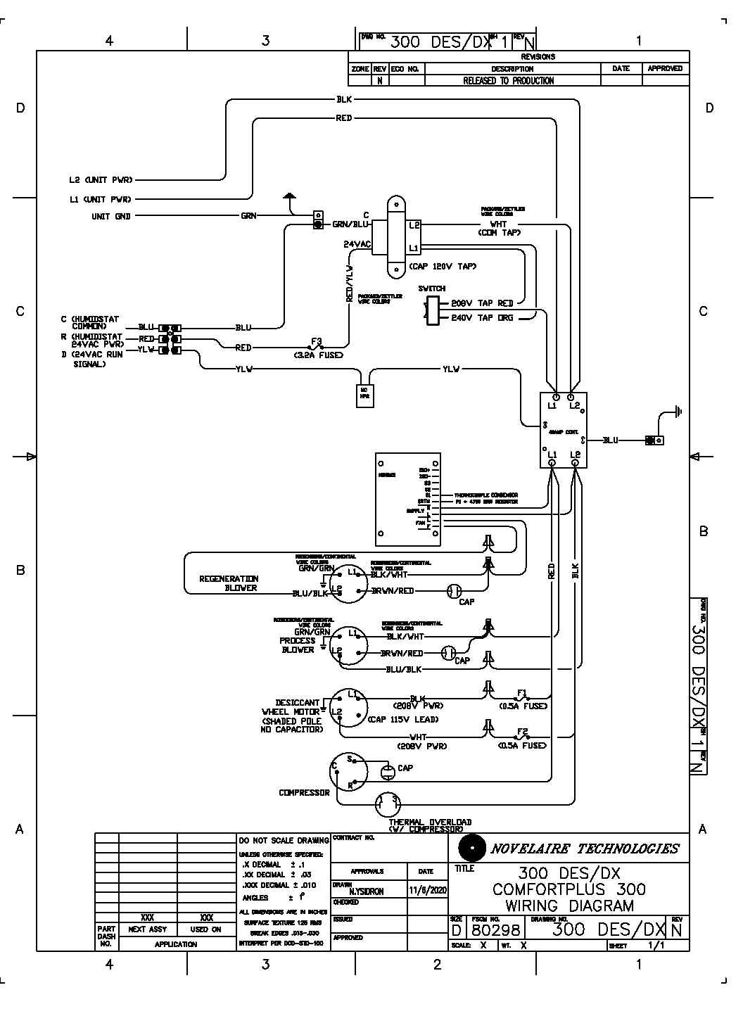

4.7 ELECTRICAL LADDER LOGIC
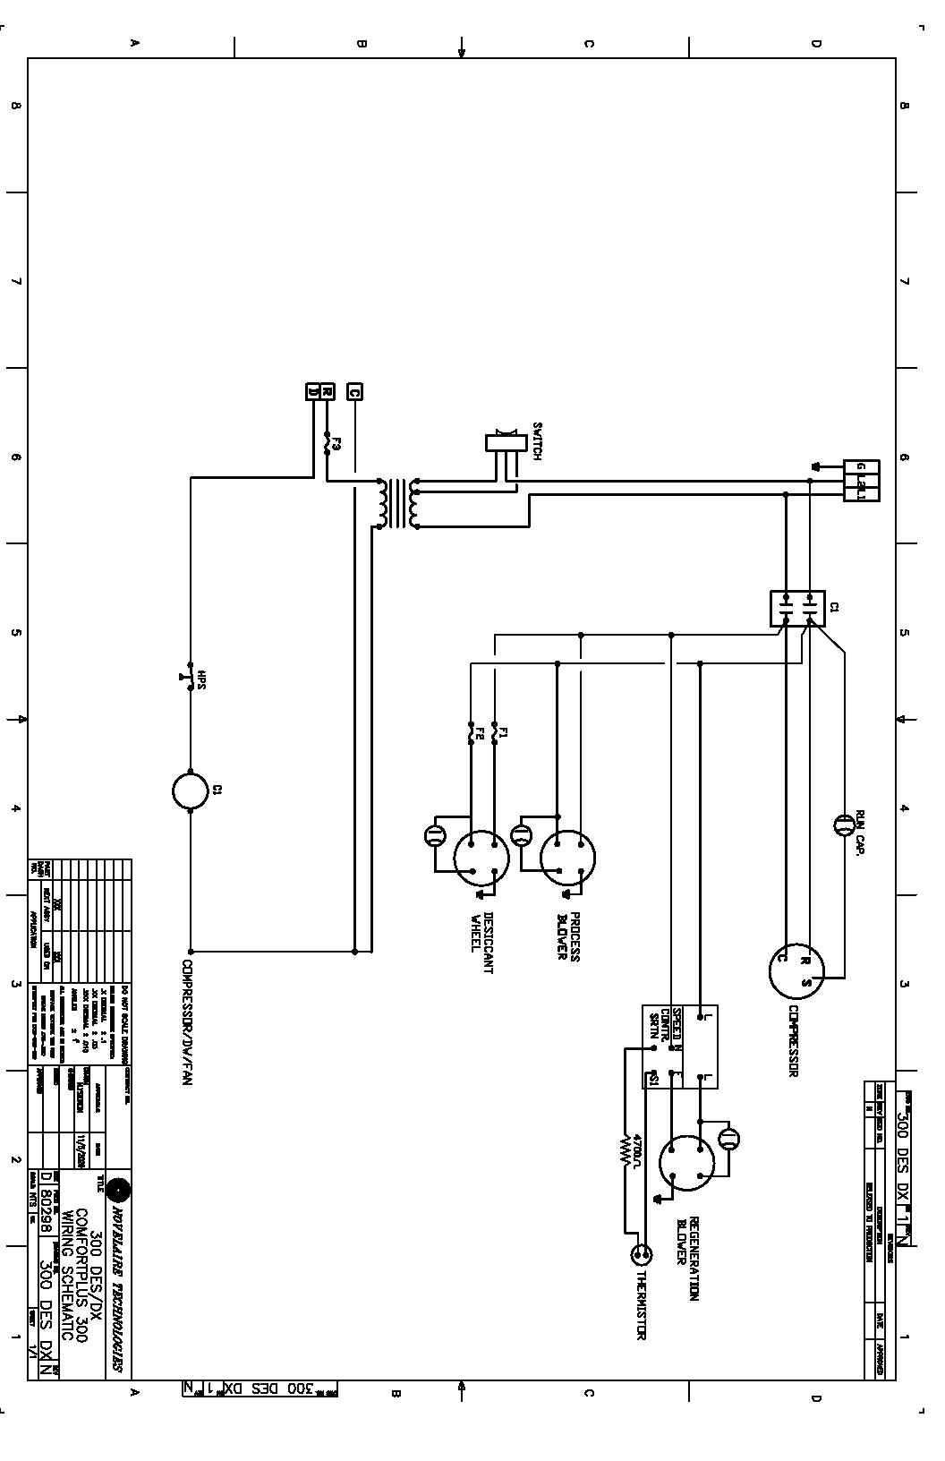

4.8 INSTALLATION DRAWINGS

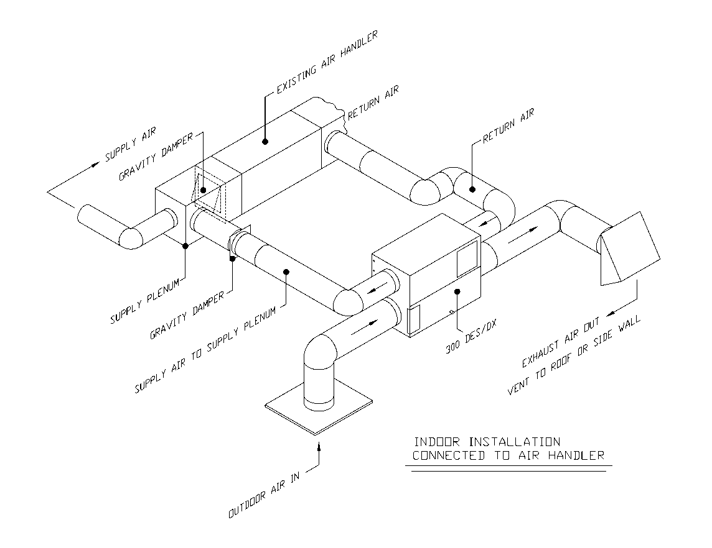

The information contained in this manual is believed to be accurate by NovelAire Technologies but is not warrantied.

Revision: 16 WT 20250501

NovelAire Technologies

10132 Mammoth Ave
Baton Rouge, LA 70814-4420
Phone: (800) 762-1320 or
(225) 924-0427

Website: www.novelaire.com
E-mail: service@novelaire.com

